Green Containers Make Biogas Plants CO₂-Negative
Bavarian Startup Reverion Brings Reversible Power-to-Gas Technology to Life with Weidmüller Solutions

While many companies strive to neutralise their CO₂ footprint, the Bavarian startup Reverion takes it a step further: their innovative power plants, housed in green freight containers, enable a negative CO₂ balance. While many companies strive to neutralise their CO₂ footprint, the Bavarian startup Reverion takes it a step further: their innovative power plants, housed in green freight containers, enable a negative CO₂ balance

A key element of Reverion’s technology is the efficient conversion of electricity into storage gas—either green hydrogen or synthetic methane—and vice versa, addressing the challenges of the energy transition. When combined with a biogas plant, these container solutions not only convert energy but can even actively capture CO₂, making it available for sustainable reuse or permanent storage—a crucial contribution to combating climate change. Reverion is supported by technology partner Weidmüller, which provides tailored hardware and software solutions to accelerate mass production and industrial implementation.

Patented Technology with Revolutionary Efficiency
Reverion’s patented technology is based on high-temperature fuel cells with a unique reversible system design. During operation, biogas, hydrogen, or methane is converted into electricity, while in electrolysis mode, the same system can transform electrical energy into hydrogen or methane. This allows excess energy to be stored as gas, which can later be reconverted into electricity when needed.

In both modes, the system achieves a groundbreaking electrical efficiency of up to 80%. Given the fluctuations in solar and wind energy availability, a flexible and reliable energy management system is essential. Reverion’s technology provides a forward-thinking solution, supporting the transition towards a climate-neutral future.

A Biogas Revolution: Greater Efficiency Through Innovation
Traditional biogas plants contribute to renewable energy generation but still release CO₂ when generating electricity via combined heat and power (CHP) units. Since this CO₂ was initially absorbed by plants during their growth, it is simply returned to the atmosphere, making the process carbon-neutral.

Reverion aims to revolutionise biogas plants by replacing conventional gas generators with their high-temperature fuel cell power plant. This system doubles plant efficiency, enabling up to 100% more energy extraction from the same amount of biogas. Additionally, CO₂ is removed from the biogas and stored as pure, biogenic CO₂, which can be reused in industries such as beverage production and breweries.

Maximum Flexibility in Operation
A standout feature of Reverion’s technology is its flexibility and rapid switching between operational modes. When there is excess electricity from solar or wind power, the Reverion unit can store it by converting it into hydrogen or synthetic methane. “In this case, our unit functions as an electrolyser,” explains Konrad Bierlein, Production Engineer for Electrical Engineering at Reverion. The generated hydrogen can be sold to hydrogen refuelling stations, while the synthetic methane can be fed into the gas grid.

Conversely, the system can switch modes in less than a minute, using the same fuel cells to generate electricity and feed power into the grid on demand, for example, during periods of low renewable energy generation. This makes Reverion a key technology for making the energy transition practical and scalable.

Best-in-Class Electrical Engineering
Inside Reverion’s green containers, advanced thermal and chemical processes are controlled by cutting-edge process technology and high-tech automation. Through close collaboration with global electrical and connectivity experts such as Weidmüller, the startup—already managing a high volume of pre-orders—has one less concern to worry about.

Smart Stack Monitoring by Weidmüller
By integrating Weidmüller components and services, the efficiency of Reverion’s plants is further increased. Weidmüller contributes its extensive expertise in automation and hydrogen monitoring, ensuring safe and efficient operation of the complex process. “Our systems guarantee precise and secure operation in both modes.

One example is the ACT20C module, which monitors voltage in the fuel cell stacks,” explains Dirk Bauerkämper, Head of Market Management New Energies at Weidmüller. These stacks, which are responsible for electrolysis and fuel cell operation, form the heart of Reverion’s technology. Their compact design, high insulation voltage, and multi-channel configuration make Weidmüller’s solutions ideal for these plants.

Another Key to the Energy Transition
As hydrogen continues to be recognised as a future-proof energy carrier, Reverion’s technology stands out because it can optimise existing biogas plants while also enabling CO₂-negative operation.

By combining renewable gas production with electricity generation, Reverion’s systems not only offer major efficiency gains but also enhance energy supply flexibility. In periods of solar and wind energy fluctuations, the technology ensures reliable reconversion of stored energy into electricity—while also providing additional revenue streams for agricultural businesses.

“While others are still developing hydrogen strategies, Reverion is already deploying the technology. This is a real game-changer. At Weidmüller, as pioneers in electrical engineering, we are particularly excited to support such groundbreaking projects,” concludes Bauerkämper.

5,751 characters including spaces

You are free to use all images. You can download them via the following link: https://www.picdrop.com/weidmueller/ADAzuJjsqn
We request that you cite the image source Weidmüller.

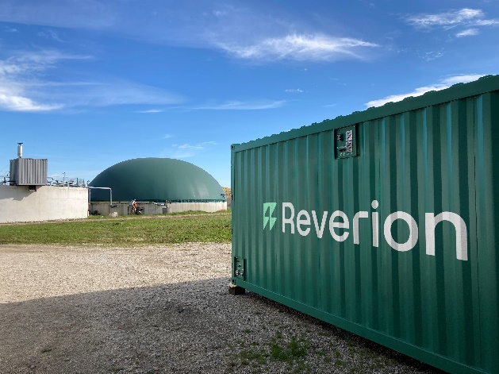
Image caption: In Reverion’s green containers, electricity is converted into storage gas—and vice versa.
Image credit: Reverion

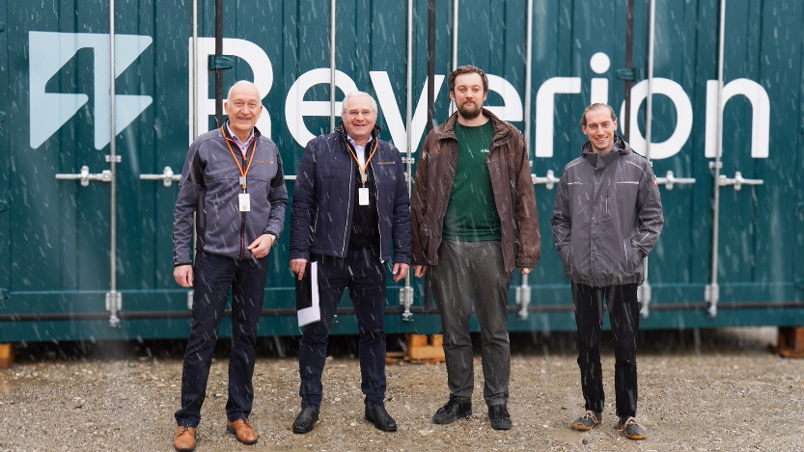
Image caption: Reverion is supported in this endeavour by its technology partner Weidmüller. The cooperation is driving forward series production and the industrial implementation of Reverion technology (from left to right: Dirk Bauerkämper, Wolfgang Nagl (Weidmüller), Konrad Bierlein, Sebastian Arend (Reverion))
Image credit: Reverion GmbH, Lisa Männel

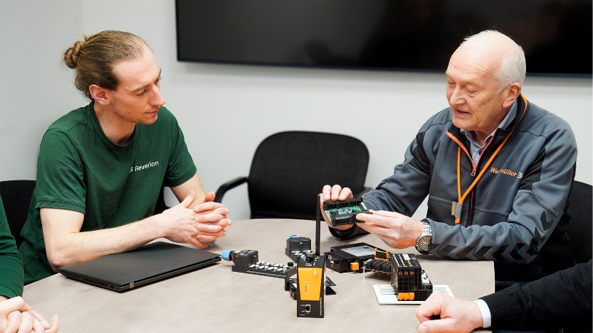
Image caption: Weidmüller's innovative products for stack monitoring are crucial for the security and efficient operation of these central system components in conjunction with the other units.
Image credit: Reverion GmbH, Lisa Männel

About Reverion
Reverion's journey began in 2015 with a groundbreaking vision: to pave the way for 100% renewable energy by unlocking the full potential of biogas. Over the years, an innovative high-temperature fuel cell system was developed and patented at the Technical University of Munich (TUM) to achieve this goal. After the success of an initial prototype, Reverion was founded in 2022 to commercialise the technology. The founding team consists of Stephan Herrmann (CEO & Managing Director), Felix Fischer (COO & Managing Director), Maximilian Hauck (CTO), Jeremias Weinrich (CPO), and Luis Poblotzki (CDO). Together, they bring more than 25 years of experience in researching and developing energy systems at TUM. Reverion is headquartered in Eresing, approximately 50 km west of Munich, where it has office and production facilities and now employs around 100 staff.

The Weidmüller Group
Smart Industrial Connectivity: Electrification, automation, digitalisation, electrical connectivity, electromobility and renewable energies – markets in which Weidmüller feels right at home. The family-owned company established in 1850 has production facilities and sales companies in over 80 countries. As a global player in electric connection technology, Weidmüller achieved a turnover of more than one billion euros in the 2023 financial year with around 6,000 employees worldwide - around 2,000 of whom work at the company's headquarters in Detmold, in the heart of East Westphalia-Lippe, Germany. What Weidmüller lives by: Diversity with respect
Technologies and engagement for a liveable future - Weidmüller demonstrates how it approaches the topic of sustainability in its interactive sustainability brochure.

Your contact:
Weidmüller Corporate Communication
Marc Landermann, Head of Corporate Communication
Tel.: +49 5231 14-292322
Email: presse@weidmueller.com

