PV Done Right – Compliant and Efficient
Experience Weidmüller's PV Solutions Live at Intersolar 2025

Intersolar Europe, taking place from 7–9 May 2025 in Munich, is recognised as one of the world’s leading trade fairs for the photovoltaic industry. As a leading provider of industrial connectivity solutions and a pioneer in the development of residential, commercial, and utility-scale photovoltaic applications, Weidmüller will once again showcase its latest solutions and product highlights in Hall B4, Stand 340. Among the highlights are the most compact surge protection device on the market, PV Inline, the PV Next Fireman Switch, as well as PV retrofit combiner boxes and weather stations.

PV Inline: Compact Surge Protection for Rooftop Systems
The new PV Inline offers reliable protection against surges – even in the event of a direct lightning strike. Thanks to the integrated SPD Type I+II, it ensures a safe earthing connection when needed. Its space-saving design allows for installation directly within cable ducts or behind PV modules, making it the ideal solution for confined installation spaces. With this innovation, PV Inline is a finalist for The smarter E Award 2025 in the Photovoltaics category.
Discover PV Inline now: https://www.weidmueller.com/int/solutions/industries/photovoltaics/solutions_for_rooftop_photovoltaic_systems/pv_inline.jsp

PV Next Fireman Switch: Automatic Safety in the Event of Fire
The PV Next Fireman Switch enables the automatic shutdown of PV strings in the event of a fire – a function increasingly demanded by insurers and emergency services. Installation is carried out at the point where the string cables enter the building. If the power supply is interrupted by the fire brigade, the system automatically disconnects the strings. As soon as power is restored, the switch reactivates the system automatically – a smart solution for PV systems of all sizes, from 1 to 12 MPP trackers.
Discover the PV Next Fireman Switch now: https://www.weidmueller.com/int/solutions/industries/photovoltaics/solutions_for_rooftop_photovoltaic_systems/pv_next_fireman_switch.jsp

String Monitoring for Greater Efficiency in Utility-Scale PV Systems
Precise monitoring at the string level helps to detect performance losses early and rectify them quickly. Using smart monitoring technology, faults, contamination or shading can be pinpointed with accuracy. This increases energy yield, reduces maintenance costs, and improves profitability – both for new installations and existing systems. Retrofit combiner boxes are a simple and effective solution for upgrading existing utility-scale PV systems with string monitoring. Thanks to wireless LoRaWAN communication, no additional cabling or civil works are required. This enables quick installation and rapid fault diagnostics on site – a real efficiency boost for operation and maintenance.
Discover Weidmüller's retrofit combiner boxes now: https://www.weidmueller.com/int/solutions/industries/photovoltaics/solutions_for_utility_scale_pv_plants/pv_retrofit_combiner_boxes.jsp

PV Weather Stations: Monitoring Environmental Factors for Maximum Performance
To fully maximise PV system yields, accurate weather data collection is essential. PV Weather Boxes continuously deliver data on irradiance, temperature, wind conditions, precipitation, and humidity. This information helps to correctly assess weather-related performance losses and optimise system operation accordingly.
Discover Weidmüller's PV Weather Stations now: https://www.weidmueller.com/int/solutions/industries/photovoltaics/solutions_for_utility_scale_pv_plants/pv_communication_boxes_pv_weather_boxes.jsp#wm-924153

Experience Technology and More at the Weidmüller Exhibition Stand
In addition to these highlights, visitors to the Weidmüller stand can look forward to further professional solutions for building installations and workshops, as well as the latest developments in energy flow management and energy storage. Visit Weidmüller at Intersolar Europe in Munich and discover the company's innovations, designed to boost the efficiency and safety of photovoltaic systems worldwide: Hall B4, Stand 340. Additionally, Weidmüller is offering a chance to win a barbecue event for PV teams of up to 30 people at their stand. Free exhibition tickets are available via the following website: https://www.weidmueller.com/int/global/intersolar.jsp

4,386 characters including spaces

You are free to use all images. You can download them via the following link: https://www.picdrop.com/weidmueller/rnDGb6UDHo
We request that you cite the image source Weidmüller.

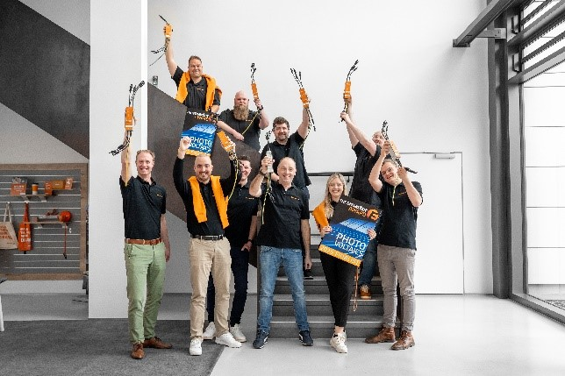
Image caption: PV Inline, the most compact surge protection device on the market, is a finalist for The smarter E Award 2025 – the team is delighted!

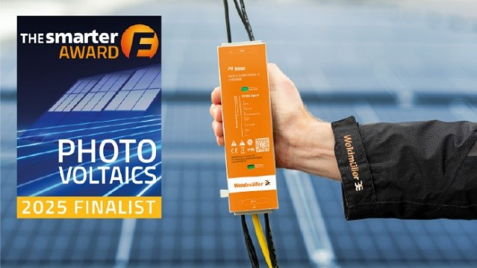
Image caption: PV Inline is the ideal photovoltaic surge protection solution for confined installation spaces

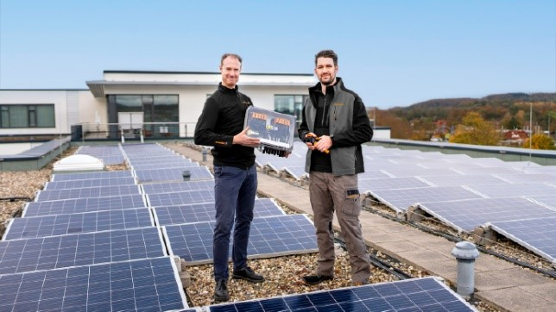
Image caption: The PV Next Fireman Switch combines PV strings, provides surge protection, and automatically disconnects systems in the event of a fire
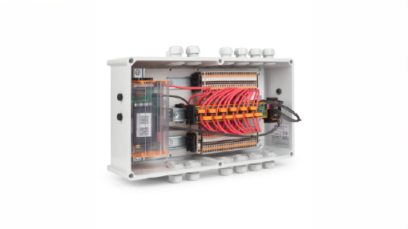
Image caption: Weidmüller's retrofit combiner boxes enable string-level data management in PV systems without existing monitoring
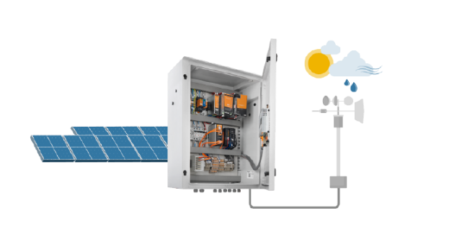
Image caption: Environmental factors affect the efficiency of solar modules, which is why real-time data collection using PV weather stations is crucial for maximising yields

The Weidmüller Group
Smart Industrial Connectivity: Electrification, automation, digitalisation, electrical connectivity, electromobility and renewable energies – markets in which Weidmüller feels right at home. The family-owned company established in 1850 has production facilities and sales companies in over 80 countries. As a global player in electric connection technology, Weidmüller achieved a turnover of one billion euros in the 2024 financial year with around 5,700 employees worldwide - around 2,000 of whom work at the company's headquarters in Detmold, in the heart of East Westphalia-Lippe, Germany. What Weidmüller lives by: Diversity with respect
Technologies and engagement for a liveable future - Weidmüller demonstrates how it approaches the topic of sustainability in its interactive sustainability brochure.

Your contact:
Weidmüller Corporate Communication
Marc Landermann, Head of Corporate Communication
Tel.: +49 5231 14-292322
Email: presse@weidmueller.com

