Announcement:
Weidmüller Pty Ltd and Solaris^{AI} Pty Ltd are excited to announce their collaborative partnership.

By harnessing the expertise of both organisations, this collaboration will leverage the University of Queensland’s (UQ) spin-out Solaris^{AI}. Their Artificial Intelligence’s (AI) predictive power will optimise solar operations and maintenance using Weidmüller’s measurement devices and supporting solutions.

This partnership started in 2020 when the research team at UQ’s School of Electrical Engineering & Computer Science (EECS) required string monitoring boxes to support a large-scale solar farm ARENA-funded project. Weidmüller supplied the Transclinic measurement device and the u-control system automation controller.

Weidmüller is an expert in the transmission and interconnection of power, signals, and data in industrial environments. Weidmüller solutions are widely used in modern production plants, power generation and railroad technology, as well as wind and photovoltaic systems. Weidmüller is a global leader in renewable energy with cumulative products and solutions that account for more than 35GW globally and approaching 4GW in Australia and New Zealand. Weidmüller is an expert in the Photovoltaic industry offering a wide range of solutions and various applications. The solutions include and not limited to combiner boxes, string monitoring solutions, weather stations and communication cabinets.

In addition, Weidmüller has jointly researched alongside UQ to optimise system connectivity, reducing installation and design efforts by using a PV-Next solution at the UQ Long Pocket Test Facility.

The Solaris^{AI} platform has been developed for solar farms and large-scale photovoltaic (PV) installations. The system can be used without the need for additional hardware by monitoring groups of PV panels at the array level, but there is also an option to add in-line current sensors to monitor at the string level. The technology is designed around the relationship of string current levels w/fault types, fault location, number of panels per string and the panel types. It uses advanced algorithms to create base and progression distribution mappings to foresee where maintenance work needs to be prioritised.

Ritesh Anand (National Sales Manager – Projects and Technology Solutions of Weidmüller Pty Ltd), “It is a pleasure to have a collaborative partnership with Solaris^{AI} as we both share a common bond for sustainability and environment conservation and protection. Our joint efforts in a technological approach to problem-solving for renewable energy has been an enjoyable journey”.

Derek Stephens (COO of Solaris^{AI} Pty Ltd), “Weidmüller was our initial industry partner during the development of our advanced data analytics & AI platform for solar farms. Their invaluable support over the years has been a key to our success. We look forward to furthering our cooperation through this collaborative partnership”.

Image 1:
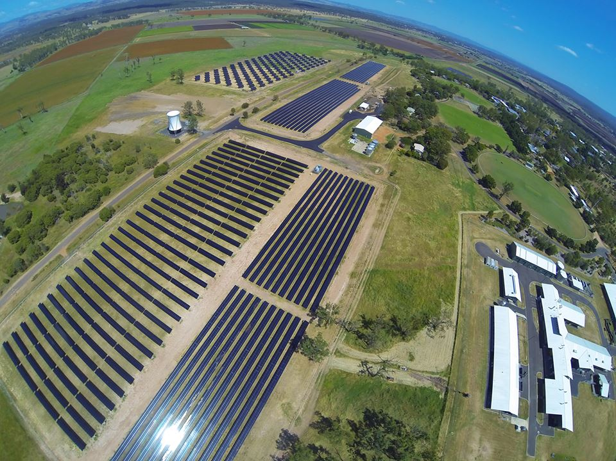
Caption: 3.3MW Gatton Solar Farm
Image copyright: Solaris^{AI} Pty Ltd

Image 2:
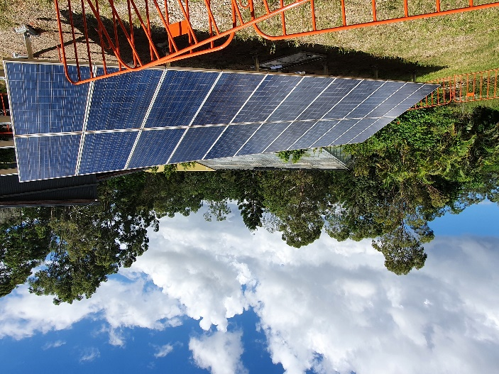
Caption: PV Panels at UQ Long Pocket Test Facility
Image copyright: Solaris^{AI} Pty Ltd

Image 3:
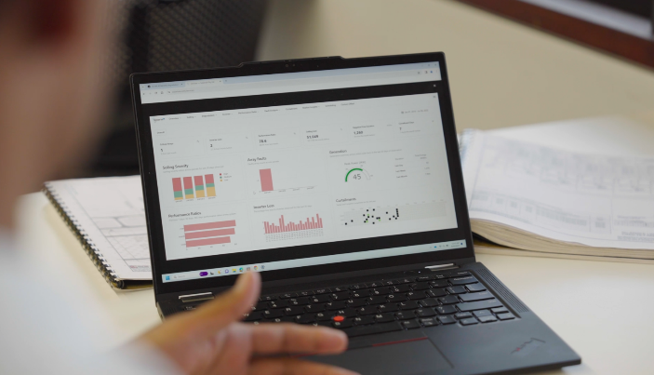
Caption: Solaris^{AI} Platform Landing Page
Image copyright: Solaris^{AI} Pty Ltd

Image 4:
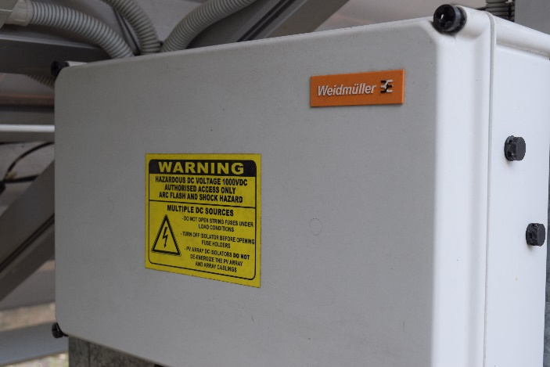
Caption: PV Panels at UQ Long Pocket Test Facility
Image copyright: Solaris^{AI} Pty Ltd

Image 5:
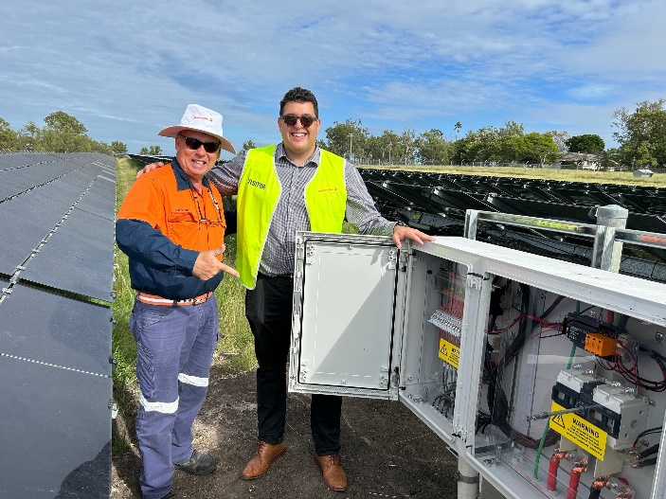
Caption: Don Drane, UQ Facility Manager (Left) and Mario Trape, Weidmuller Lead R&D / Operations Engineer – Renewable Energy (Right)
Image copyright: Solaris^{AI} Pty Ltd

Weidmüller

Smart Industrial Connectivity: Electrification, automation, digitalisation, electric connectivity, electromobility and renewable energies - markets in which Weidmüller is at home. Founded in 1850, the family-owned company is represented in over 80 countries with production facilities and sales companies. As a global player in electric connection technology, Weidmüller achieved a turnover of more than one billion euros in the 2022 financial year with around 6,000 employees worldwide - around 2,000 of whom work at the company's headquarters in Detmold.

Solaris^{AI}

Solaris^{AI} Pty Ltd is a UQ spin-out led by Associate Professor Rahul Sharma from the School of EECS. Solaris^{AI} is a software-as-a-service (SaaS) platform using advanced data analytics & AI. The system uses advanced algorithms to analyse customer solar farm data to maximise energy output and reduce operation & maintenance costs.


