Faster commissioning and more efficient operation for open space PV plants
Significant cost benefits from combining blueplanet string inverter from KACO new energy with Weidmüller DC combiner box

Adding capacity in photovoltaic plants is a core part of the energy transition. Investment in PV plants therefore needs to be made as attractive as possible for operators. To make the planning, construction and operation of PV plants more economical, KACO new energy has developed its unique Virtual Central concept, which replaces a central inverter with multiple string inverters centralised in one place. The cost-saving concept is made possible through collaboration with the connection technology specialist Weidmüller, who contribute the DC combiner boxes with the appropriate equipment.

Combining benefits
Central inverters are better suited to large-scale PV plants in which the angle and alignment of the PV modules are similar. For smaller and medium-sized roof-top and open space plants, string inverters are the preferred choice. They can compensate differences in the power of individual modules and module rows caused by alignment and reduce unavoidable mismatching losses. Yet their localised structure makes conventional string inverter concepts complex to install, monitor and maintain, while the long AC cable routes cause significant power losses. The unique Virtual Central concept of the blueplanet inverter from KACO new energy, which can be used even on large plants, minimises these disadvantages significantly.

Reduced distribution losses through centralisation
“Our idea was to install the string inverters in a central position in the PV plant, while the DC combiner boxes are spread across the field,” explains Cristen Schimpf, Head of Product Lifecycle Management for Photovoltaik and Storage at KACO new energy. “That makes the cable lengths between the inverter and the transformer short, so distribution losses on the AC side are minimal. The power loss can be reduced by up to 1.5%. That allows the high efficiency of the inverters to be fully exploited, prevents unnecessary AC lines, and ensures that the defined power at the AC connection is achieved. At the heart of the concept are the DC combiner boxes developed by Weidmüller, whose specific equipment allows the design of the PV plant to be highly flexible.

DC combiner boxes to fit the application
Weidmüller produces the DC combiner boxes for the system in many standardised versions available off the shelf – tailored to the various inverter types from KACO new energy. As a result, country-specific regulations and individual project specifications can be implemented easily. The DC combiner box is available in an IEC 61439-2-compliant design for DC system voltages up to 1,500 V with 20 to 30 A fuses, integrated surge protection, a flexible number of DC inputs and optional string monitoring. DC combiner boxes equipped for specific projects are also available, for example with connection options using plug-in connections, fuse protection on the plus and minus side depending on the module type, and various additional functions. “For example, we can integrate a rapid shutdown function or a fireman’s switch for safe remote shutdown of the plant,” explains Markus Priester, Key Account Manager Energy at Weidmüller. “Fuse protection can also be provided against currents over 25 A, as is needed for bifacial solar modules.”

Higher plant efficiency at 10% lower investment costs
The solution with blueplanet inverters has enormous benefits compared with localised inverters. These include greater flexibility in plant design, better suitability for high current solar modules, more efficient operation, easier maintenance, faster installation and commissioning, and a superior revenue-power ratio. The central concept results in costs up to 10% lower for the electrical infrastructure of a PV plant. “Our studies up to now indicate that our solution allows more energy to be fed into the power grid, increasing the operator’s revenue. It is a side benefit that makes the investment pay off even faster,” emphasises Cristen Schimpf.

Simple planning and ordering – fast delivery
Close cooperation between KACO new energy and Weidmüller allows the combiner boxes to be tailored perfectly to the respective plant. To offer planners and decision-makers the best possible project support, at KACO new energy inverters, combiner boxes and panels can be incorporated directly into the plant design. In addition, the inverters and combiner boxes can be ordered together from KACO new energy. Harmonised item numbers for inverters and combiner boxes make the order process easier, while high delivery capacity ensures that the project is implemented on schedule – a clear advantage in an age of high demand.

4,789 characters including spaces

Image caption: The Virtual Central concept from KACO new energy puts the blueplanet string inverters in a central location in the plant – ideally close to the grid feed-in. This significantly reduces investment and operating costs and energy losses.
Image source: KACO new energy

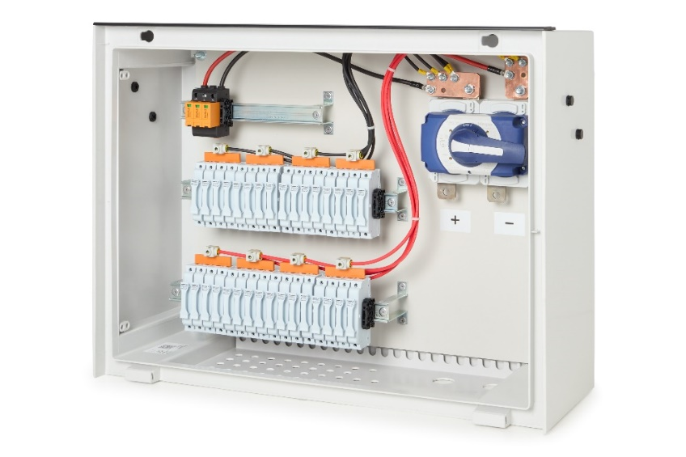
Image caption: The DC combiner boxes supplied by Weidmüller for the KACO blueplanet string inverter solution are tailored precisely to the respective requirements.
Image source: Weidmüller

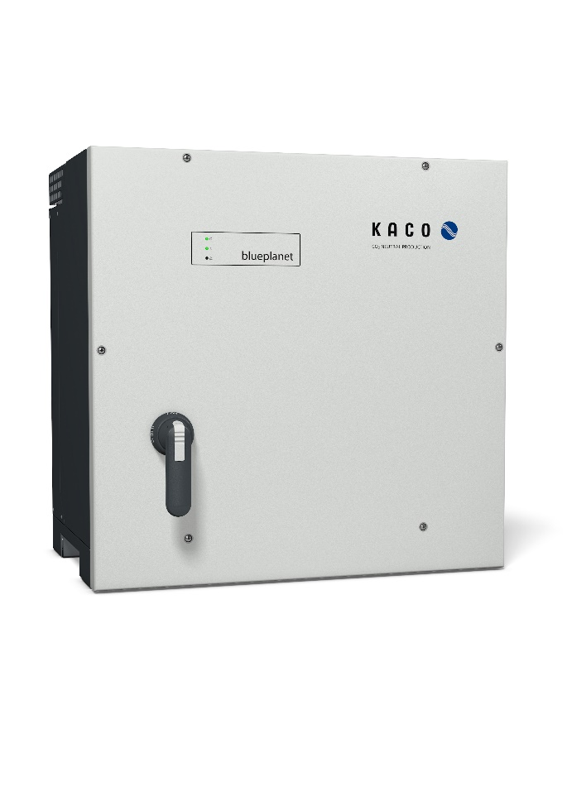
Image caption: Combining the blueplanet string inverter from KACO new energy with the Weidmüller DC combiner box makes significant cost benefits possible.
Image source: KACO new energy

Your contact person: Weidmüller Corporate Communications
Tel.: +49 5231 14-292322
Email: presse@weidmueller.com

Weidmüller – Partner of Smart Industrial Connectivity
The Weidmüller Group has production sites, sales companies and representatives in more than 80 countries. Together with its customers, the Detmold-based family business is shaping the digital transformation – with products, solutions and services for smart industrial connectivity and the Industrial Internet of Things. In the 2022 fiscal year, Weidmüller generated a turnover of more than one billion euros with about 6,000 employees around the world.

Responsible for the content: Weidmüller Corporate Communications
Corporate Spokesperson, Sybille Hilker

