**“easyConnect – easy digital services throughout the entire product life cycle"**

*In the future, the easyConnect industrial service platform will bundle all digital services relating to Weidmüller products. As a companion along all phases of the product life cycle, easyConnect goes beyond the scope of conventional IIoT platforms: easyConnect offers an integrated modular solution for a wide range of use cases – from planning and installation to the operation of devices, machines and systems.*

**easyConnect – your platform for planning, installation and operation**

easyConnect simplifies all essential steps for the user – from planning to the installation and operation of a machine. For the planning phase, easyConnect provides configurators that can be used to configure the hardware according to the machine’s requirements. This means that easyConnect will replace the Weidmüller Configurator (WMC) in the future. The WMC had to be installed by users first. easyConnect makes the configuration service web-enabled and enables access via the cloud.

easyConnect also offers decisive advantages in the installation phase. The platform simplifies the handling of software on the device: Device configuration and parameterisation, which previously could only be performed on the machine itself, can in future be created in easyConnect and distributed to all devices via the rollout management service from the cloud. Thanks to the close connection to the u-OS operating system, apps can be integrated on Weidmüller devices with ease.

During operation, users benefit from data visualisation, remote maintenance and analytics services. For example, AutoML (Automated Machine Learning) designs intelligent analysis models. Anomaly detection and predictive maintenance no longer require in-depth programming knowledge.

Users can stay flexible with easyConnect. They decide for themselves which functions they want and to what extent they want to use easyConnect. Depending on the user’s needs, functions can easily be added via the licence management.

**Continuous further development of the industrial service platform**

All these services are gradually being integrated into the platform. In this process, Weidmüller is in constant exchange with customers. Based on their feedback, Weidmüller is continuing to expand easyConnect and ensure that the best possible platform is developed for the user. In addition to the configuration of device connectors and top-hat rail-based components, automation products will also be configurable in easyConnect in the future. Moreover, the range of IIoT offerings will continue to grow. In this way, Weidmüller is at the user’s side in every phase of the product’s life and empowers users on their journey into the IIoT.

2745- characters including spaces

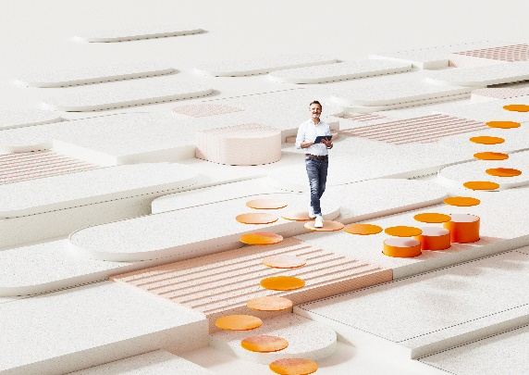

Image caption: The digital services of the Industrial Service Platform easyConnect accompany the user through the entire product life cycle.

**Your contact person:** Weidmüller Corporate Communications

Tel.: +49 5231 14-292322

Email: [presse@weidmueller.com](mailto:presse@weidmueller.com)

**Weidmüller - Your Partner in Industrial Connectivity**

The Weidmüller Group has production facilities, marketing companies and representative offices in more than 80 countries. Together with our customers, we shape the digital transformation – with products, solutions and services for Smart Industrial Connectivity and the Industrial Internet of Things. In the fiscal year of 2021, Weidmüller reached sales of 960 million euros with around 5,300 employees.

**Responsible for the content:** Weidmüller Corporate Communications

Corporate Spokesperson, Sybille Hilker